PW201A-Why the adapters failed to establish a powerline network after connection

Product line: powerline question category: trouble shooting

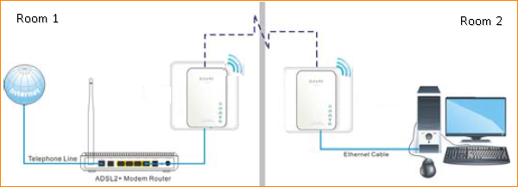

Reasons:
They are plugged into the different electricity meters.
They can’t find the same network name from the other powerline devices.

Solutions：
1. Please plug the PW201As into the same electricity meters. The power line adapter only work in the same electricity meter.
2. Please press the Reset button for at least 10 seconds of all the PW201A to restore them to factory default, so that they will have the same network.

A. After reset, please wait for about 2 minutes then check the Powerline light of all the PW201A, if they are all on or blinking fast, it means that they have established the powerline network successfully.

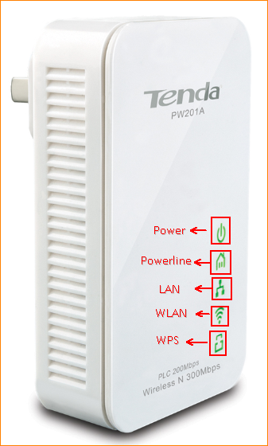

B. If it the powerline light is still off or flashing slowly, please press the Pair button for about 3 second for the first PW201A, then do the same thing on the other PW201A within two minutes.
Tips: Please setup the powerline network in the same outlet or in the same room first, then take them apart to the places or rooms where you want to use them.

C. If they still can’t pair to each other please login to the management page of them to change the the PLC Network name of them to the same one and add them to the same network manually.

Click this link to check how to login to the management page.

Click Advanced to go into the advanced setting page.
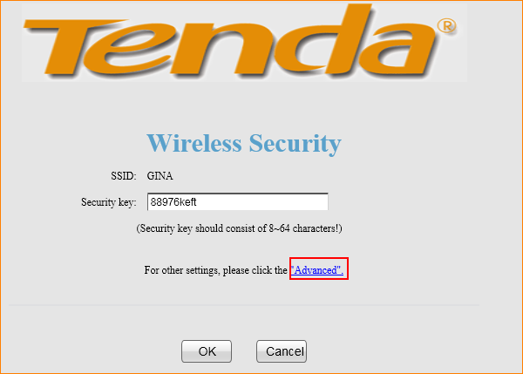
Click PLC, then check the Network Name of it, make sure that all of the PW201A has the same Network Name, otherwise, change them into the same.
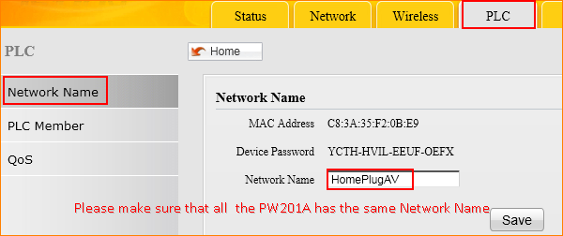
After changing all of the PW201A’s Network into the same one, check the PLC Member

If the PW201A has joined the same network, you can see them in the PLC Device List. Otherwise, please add them manually.
